GCSE and Mocks

Examinations Guide
Class of 2020

Information for Candidates and their Parents

Message from the Principal – Mr Knowles

Less than 100 days to go (from 1000!). You are coming to the end of your marathon, the end is in sight. Treat your mock exams with the same focus as you will in the summer. Your mock results will provide your predicted grades for summer (and therefore the grades for colleges that we have to send BEFORE your summer GCSEs) They will also help your teachers decide which tier of exam paper you will be entered for.

Do your best, answer all the questions you are asked to do. Remember even if you don't know, guess! If you write nothing you are guaranteed no marks, if you try then you may get something.

Make your families proud, make your teachers proud and most importantly make yourselves proud.

You WILL succeed

The fate of our country won't be decided on a battlefield, it will be determined in a classroom.

Exam Entries and Timetable
GCSE entries are sent to the exam boards during February half term. Statement of Entry are given to candidates before this deadline. These must be checked by you to ensure all your entries are correct. Any errors or missing entries please inform Mrs Mundy, Examinations Officer immediately.
Preparing for the Exam
In April we will issue Individual Candidate Timetables. The Timetable will show the date, time, examination room and your seat number for each of your examinations, except the modern foreign languages speaking and other practical examinations. DO NOT LOSE IT.
You should plan your revision schedule around your personal timetable.

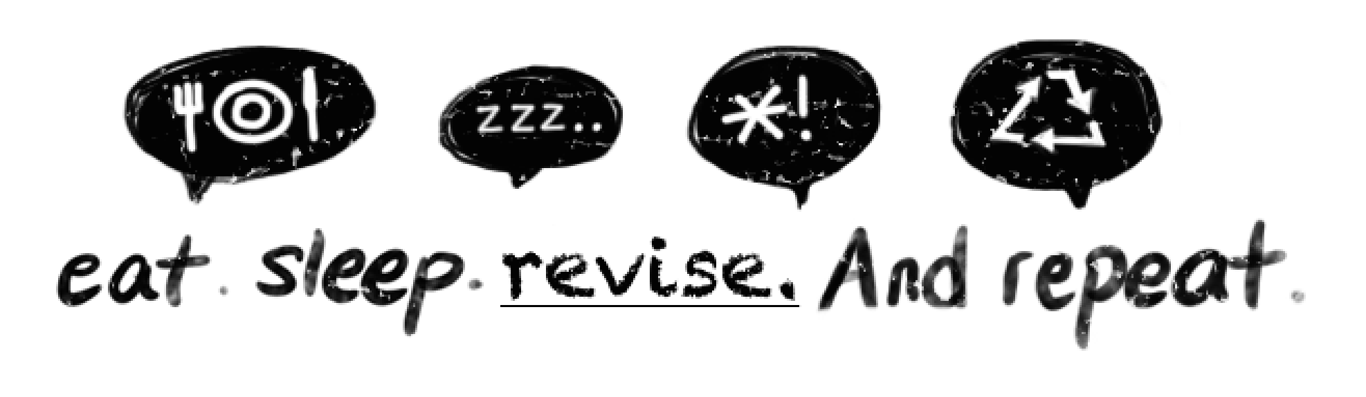

On the Day of the Examination

- Eat breakfast
- Arrive 30mins early
- Mobile phone, iWatch, glasses case, notes etc in your bag. Nothing can be taken into the exam room with the exception of stationery in a clear pencil case. All equipment is provided. NO MOBILE PHONES IN THE EXAM ROOM – NO EXCEPTIONS!

- Check your timetable for your seat number
- Clear case on the desk – Empty your pockets!
- Do not write on your exam paper or open it until you are told to
- Listen to the instructions from the Lead Invigilator
- Check you have the correct paper including Higher or Foundation
- Stay on task during the examination
- Use all the time allocated. Finish early – check your answers
- Remain quiet at all times
- DO NOT DISTURB OTHERS
- No item may be borrowed from another candidate
- Any questions – raise your hand for an invigilator
- Remain seated in silence until your row is dismissed
- Good Luck Year 11

Frequently Asked Questions

Q. What do I do if there is a clash on my timetable?

The academy will re-schedule papers internally (on the same day) where there is a clash of subjects. Candidates will normally sit one paper then have a break during which they will be supervised and isolated, as they must not have any communication with other candidates. They will then sit the second subject paper. Correct times should be on your individual candidate timetable. If in doubt, please consult the Examinations Officer. No exam session must exceed three hours (with the exception of extra time candidates).

Q. What do I do if I forget my Candidate Number?

Candidate Numbers are printed on ID cards, which are displayed on your desk in the examination rooms.

Q. What do I do if I feel ill during the examination?

Put your hand up and an invigilator will assist you. You should inform an invigilator if you feel ill before or during an examination.

Q. If I miss the examination can I take it on another day?

No. Timetables are regulated by the examination boards and you must attend on the given date and at the given time.

Q. Do I have to wear school uniform?

Yes. Normal school regulations apply to uniform, hair, jewellery, make-up, etc.

Q. What equipment should I bring for my examinations?
Essa Academy will provide all your equipment. This will be on every exam desk. If you do bring your own it should be in a clear pencil case.

Q. What do I do if the fire alarm goes off?

The examination invigilators will tell you what to do. If you have to evacuate the room, leave everything on your desk and leave the room in silence. You must not attempt to communicate with any other candidates during the evacuation.

Q. What do I do if I don’t get the grades I need/expect?

Teaching staff will be available to advise you on results day. If you feel strongly that it is necessary to make an enquiry about your result, you should first consult the Head of Faculty to obtain their advice. You should be aware that your mark could go down as well as up or even stay the same. Review requests must be submitted to the Examinations Officer by the date on the form.

GCSE Revision Tips

- Create a Revision Timetable

Building a revision timetable can add structure to your revision and help you identify which GCSE subjects you need to prioritise to get better marks. Creating a revision timetable is a great way to organise your study time, plus it also helps boost your motivation to revise for your exams.

- Take Regular Study Breaks

Do you feel stressed, tired and that no new information is entering your head? There is no point forcing yourself to study for hours upon hours as this will not result in a positive outcome. Taking regular study breaks and exercising is proven to engage your brain to study and improve your exam performance in the long-run.

- Practice, Practice, Practice

One of the biggest recommendations that past GCSE students recommend is to do as many GCSE past papers as you can. Practising past papers will help you get familiar with the exam format, question style, time pressure and overall improve your ability to retrieve information quicker.

- Variety is the Spice of Life!

Mix up your study habits and methods by listening to podcasts, watching videos or documentaries, moving to a new study area or even something as simple as using different colours for your study notes. This is different to the other GCSE revision tips mentioned here as it encourages you to try a few different things to see what fits you. Your brain will recall where you were or how you revised for a topic which will help you remember more information. Give it a go!
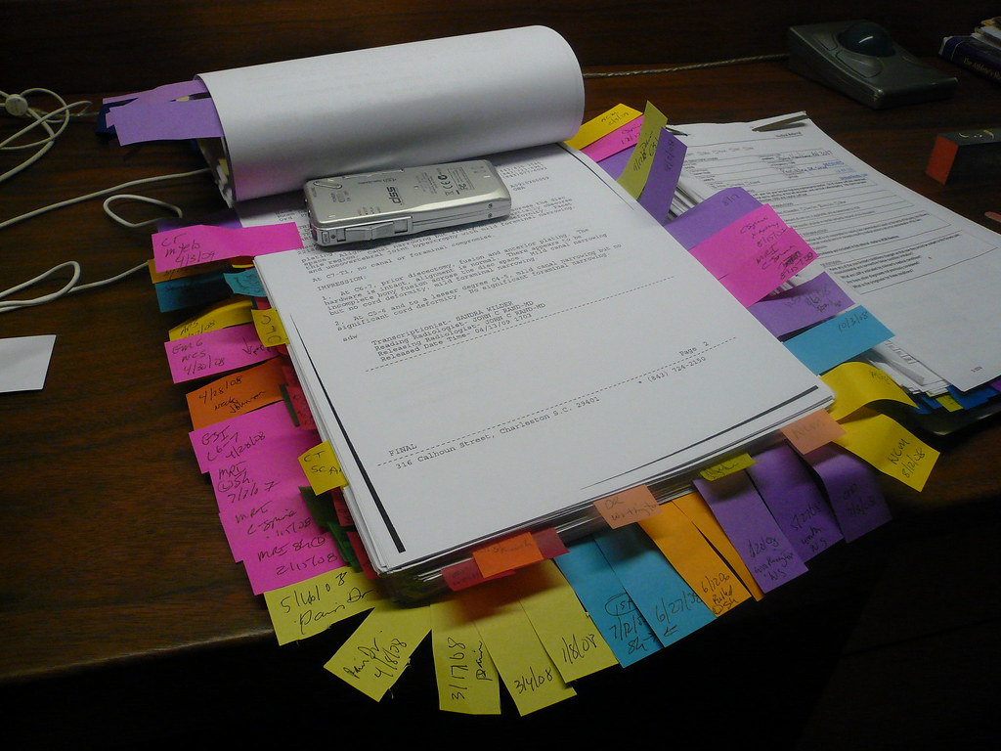

- Sleep.

If your brain is tired you won’t be able to recall information. Turn your phone off, snapchat etc can wait, nothing is that important. 8 hours sleep gives your brain time to unwind and store the information you have taken in that day.

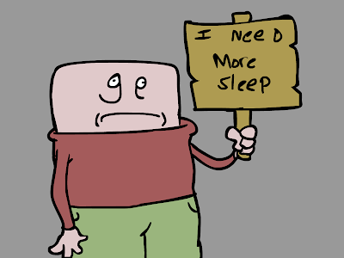

- Find the space.

Homes can be busy and noisy and you will not learn with distractions. Find a quiet space if not at home then maybe at a relatives? Or the local library? Or stay at school? You can control your environment.

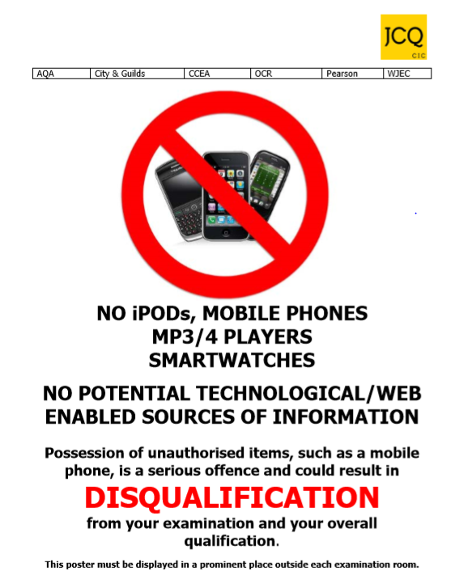

“All Will Succeed”

Exam Check List

Check your Exam Timetable Every Day!

- Aim to arrive at school as least 30 minutes before the start of the exam.
- Mobile Phones and Watches – students should hand these in (turned off) or leave in your bag before entering the exam room.

- iWatches, iPods, MP3 players or headphones are not allowed in the exam room.
- No talking or communication between students once you enter the exam room. Any questions then raise your hand once seated and an invigilator will come to you.

- No food or chewing gum is allowed in the exam room.

- Water bottles are allowed in the exam room if necessary. These have to be clear bottles with the label removed.

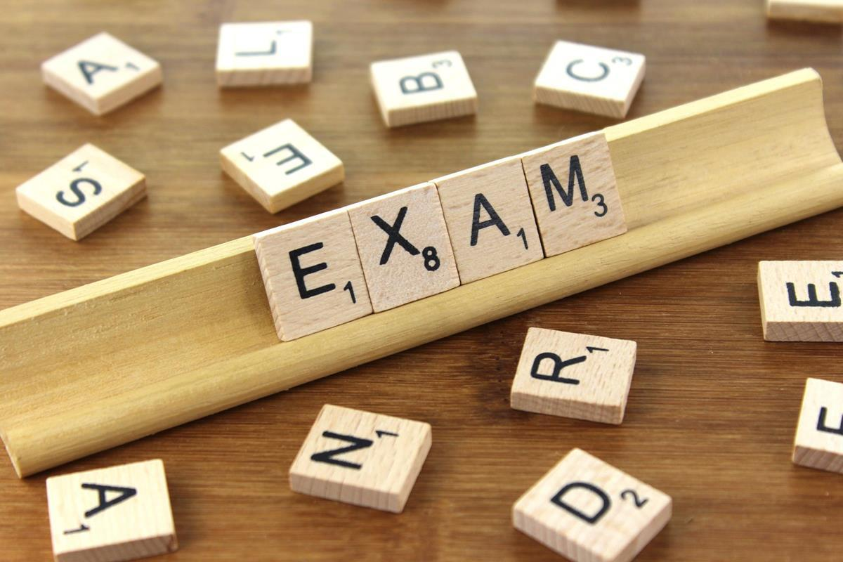

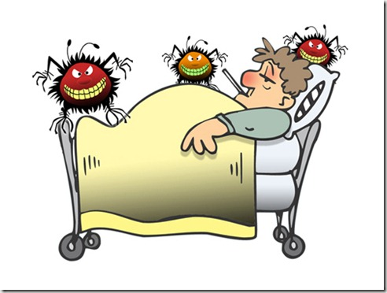 What to do if you are ill on the day of an actual GCSE exam

- If you are ill and are unable to attend an exam it is vital you phone the academy first thing in the morning on 01204 333222 to inform us.

- You must also obtain a note from your doctor detailing the reason for non-attendance. There is the possibility of submitting this note to the Examinations Board to ask for special consideration. The Board looks at this in conjunction with other exam marks from the student in that particular subject, coursework marks and mock exam marks. This will then sometimes enable them to adjust the mark and grade accordingly.

- If you are feeling unwell, but still able to travel, I suggest you come to the exam and we can assess the situation then. In most cases it is better to take the exam if you can.

- If in any doubt – PHONE THE SCHOOL

If you do not attend an exam without a valid reason, you will be charged for the exam.

